Name : Farne, Jian Ira Olvido
UOWID : 7433645
Assignment : 03
Document : Word Document Report
- INTRODUCTION
In this report, I will discuss how I structured and implemented a program that reads in and processes some messy records and how the foundation of the code relates to generic programming templates, operator overloading, STL, and writing io manipulators. The program is coded with C++ program that reads-in and processes data that are jumbled up and unsorted.

- OVERVIEW
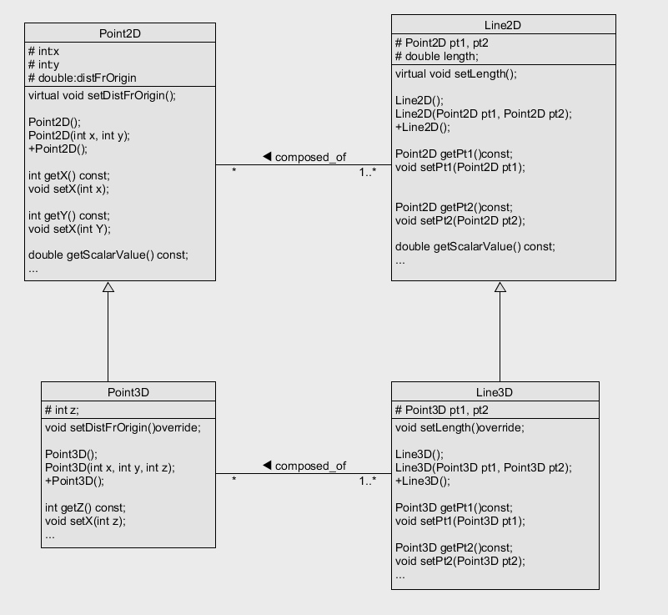
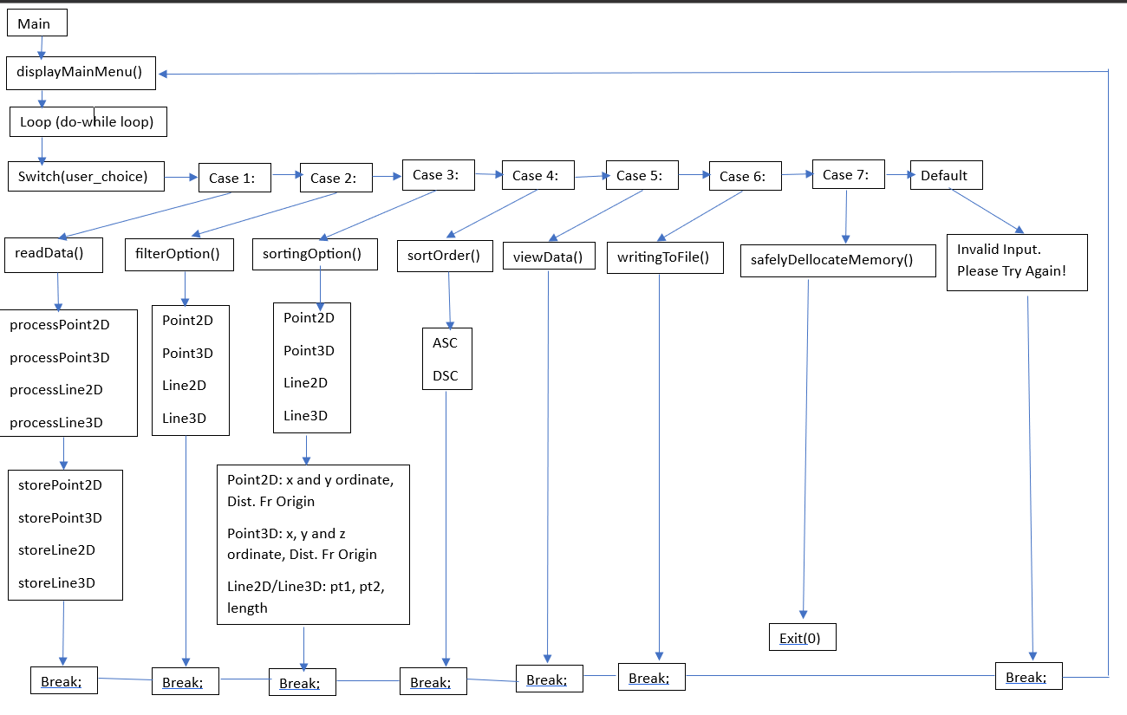
The structure I've designed focuses around a loop, allowing users to press only the Enter key as input to proceed. This ensures that we're on the same page and that data processing begins seamlessly once the loop is exited.

To facilitate the parsing of user input, I've created the "splitString" method. It is a method that splits strings using specific delimiters, enabling me to extract relevant data from the user's text file containing "Point2D," "Point3D," "Line2D," and "Line3D."

Once the data is in hand, I've created the "readData" function to manage the reading and processing of this input data. This step is crucial for it goes through the data, removing any duplicates or non-unique entries using vector operations. This way, I'm able to guarantee that the output I provide is unique.

It continues with separating the processed data of "Point2D," "Point3D," "Line2D," and "Line3D" into their respective vectors. These vectors hold the required attributes of each entity for processing.

The program doesn't just stop at processing; it's equipped with options to filter and sort the data as per assignment 3 specifications. With "filterOption," "sortingOption," and "sortOrder" methods, it allows you to decide how you want the data presented.

The "viewData" method allows you to use filtering and sorting preferences, displaying the processed and sorted data just the way you like it. I've included additional methods for sorting each entity type based on attributes such as X or Y ordinates and distance from the origin.

There's the "writingToFile" method, a program that writes the meticulously processed and sorted data to a .txt file, ensuring that you have a record of the results.

I use "MyTemplates.h," a section housing templates for operations like sorting and comparisons. These templates filter and sorts activities in the program, making sure the process is coherent.

In conclusion, the program revolves around transforming raw geometric data into structured and sorted outputs. The emphasis is on offering you control over filtering, sorting, and the final data presentation. The program is built to make your interaction with the data seamless and productive.
- REFLECTIONS
After having mastery with creating and using templates, I used it a lot in this assignment. It also allowed me to debug, find errors and fix the code easier.
IO manipulation techniques helped in present data outputs.
- PROBLEMS
Learning extern. I studied up on extern for I declared global variables in the main function file.
Sorting Algorithms. It took a bit of time from research to understand which sorting algorithms to use because I must understand each.

